Parish Bulletin Announcement for placement as space allows:

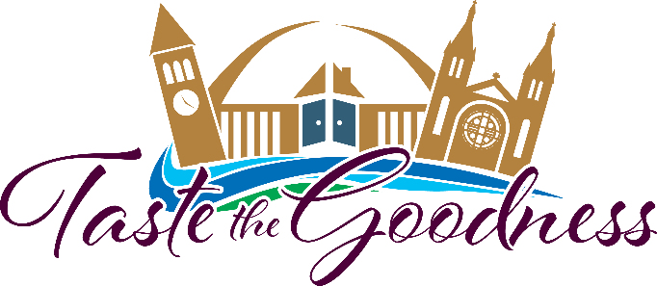

**SAVE THE DATE** - The Catholic Community Foundation is excited to announce that the **“Taste the Goodness”** event, benefitting the **Bishop Dudley Hospitality House,** will take place on Saturday evening, **August 14, 2021 from 5:00 to 9:00 p.m.** outdoors in downtown Sioux Falls.

Come with your friends to enjoy tastings of a wide variety of foods, craft beers, wine, bourbon and much more. Music and fun will be provided along with a great mobile bidding silent auction!

For on-going event updates or to purchase your ticket to Taste the Goodness, visit our website [www.ccfesd.org](http://www.ccfesd.org) or call 605-988-3765. Now more than ever, the mission of the Dudley House needs our support.



Purchase your tickets and plan now to attend the **2021 *Taste the Goodness*** event scheduled for Saturday, August 14 from 5:00 – 9:00 p.m. Held outdoors in downtown Sioux Falls, attendees can plan on a great evening of fun and fellowship while tasting a wide array of foods, craft beers, wines, and other beverages. Music will be provided, along with a great mobile bidding silent auction, exciting games and activities. This is a come and go event, so if you are unable to attend the entire evening, you are encouraged to join us when you can.

Did you know that in 2020 the **Bishop Dudley Hospitality House** provided services to 1,549 different individuals, 44 families, including 78 children, served 29,248 lunches and provided 15,758 showers? All these individuals were provided meals, housing, programs, and above all – LOVE!

For on-going event updates or to purchase your ticket to ***Taste the Goodness***, visit our website [www.ccfesd.org](http://www.ccfesd.org) or call 605-988-3765. Now more than ever, the mission of the Dudley House needs our support.

*Matthew 25:40* *“The King will reply, ‘Truly I tell you, whatever you did for one of the least of these brothers and sisters of mine, you did for me.’*