**Bulletin Announcements**

**For immediate release as space allows:**

**The 28th Annual**

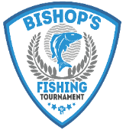

“BISHOP’S CHARITY FISHING TOURNAMENT”

### Benefiting Seminarian Education

### Fishing for a Few Good Men

The 28th Annual *“Bishop’s Charity Fishing Tournaments”* are scheduled for **Monday, June 5th** at Big Stone City - Douthitt Park and **Monday June 12th,** at Pierre - Oahe Downstream Recreation Area (located 5 miles north of Pierre).

We are excited to gather again in support of the future priests of our diocese! Join us as a sponsor, make a donation or as a participant! To register your team contact the Catholic Community Foundation at 605-988-3765, or on-line at [www.ccfesd.org](http://www.ccfesd.org).