**Bulletin Announcement**

**For Immediate Release as space allows:**

**Register today for the**

Bishop’s Cup Golf Tournament

### *Benefiting Broom Tree Retreat & Conference Center*

Monday, August 19th   
Minnehaha Country Club and The Country Club of Sioux Falls

Morning Round 7:30 AM shotgun start   
Afternoon Round 12:30 PM shotgun start

Join us for the 31st annual Bishop’s Cup at Sioux Falls prestigious golf courses for a day on the golf course with co-workers, friends, family and fellow parishioners.

Registrations are filling quickly, we encourage all parishes to gather a team or sponsor your Priest and join us on the course and at the banquet.

How can I support Broom Tree?

1. Register to play the morning round: played only on TCCSF, reserved for individual teams and sponsors who prefer the morning round.
2. Register a team to play the afternoon round: reserved for Birdie and above sponsors, played on both MCC and TCCSF
3. Not able to join us? Sponsor your priest and allow them the opportunity to meet other parishioners and community members.
4. Become a hole sponsor: hole signs will be placed on the courses to promote your parish, business, family or any intention.

Your support will ensure Broom Tree continues to available for years to come! To learn more about our upcoming events or to register visit ccfesd.org/events or scan the QR Code.

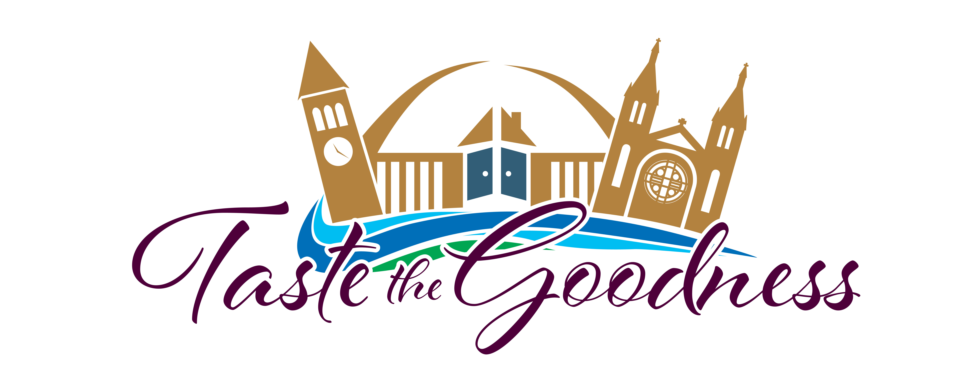

**Join us at Taste the Goodness!**

### *Benefiting Bishop Dudley Hospitality House*

Saturday, August 3rd   
Downtown Sioux Falls under tents in the parking lot of the   
Avera Technology Building

5:00-9:00 PM

Join us for an evening of fun in Downtown Sioux Falls in support of the Bishop Dudley Hospitality House! Enjoy unlimited tastings of food, beer, wine, bourbon and a variety of non-alcoholic drinks. The evening will include music, games and an amazing silent auction – all outdoors under tents. Join us for a night of flavor, fun and fellowship while supporting those in our community in most need of our help.

Tickets are on sale now for $45.00 and will be available at the gate for $50.00. Scan the QR code below to purchase your tickets.

*This event is for 21+. Attendees will be ID at the gate*

*Additionally*, we are in need of volunteers to make this event a success, if you are interested in helping set up on Saturday

morning or assist throughout the event please sign up at

ccfesd.org/events or call our office at 605-988-3769



